Earthquake Data Analysis
ESC 113 — Engineering Coding Project | October 1–31, 2026 (UTC)

Introduction
This project examines the frequency, magnitude, and depth of earthquakes using records from the U.S. Geological Survey (USGS). The purpose is to practice Python data analysis and consider which earthquake characteristics may matter in civil and structural engineering.

Data and Methods
The data come from the USGS Comprehensive Earthquake Catalog (ComCat), queried for October 1–31, 2026 (UTC), worldwide, with magnitude 4.0 or greater. The downloaded file contains 1,421 records; 1,421 records have usable magnitude and depth values. The original CSV was kept unchanged. The analysis uses Python and pandas for loading, statistics, classification, and filtering, and matplotlib for graphs.
Magnitude groups are 4.0–4.9, 5.0–5.9, 6.0–6.9, and 7.0+. Depth groups are shallow (under 70 km), intermediate (70–300 km), and deep (over 300 km). A screening filter selects events of magnitude 5.0 or higher and depth under 70 km. This filter identifies events worth examining, not events proven to have caused damage.

Results
The analyzed catalog has 1,421 events. Mean magnitude was 4.60, with a range from 4.00 to 7.70. Mean depth was 71.8 km, with a range from 1.0 to 644.4 km.
The most common magnitude group was 4.0–4.9 (1,201 events). The most common depth group was shallow (1,064 events). The engineering screening filter selected 193 events. The Pearson correlation between magnitude and depth was -0.152.
Largest event: magnitude 7.70, 10 km WSW of Pitaloza Arriba, Panama, 2026-10-09 17:56:05.537000+00:00, depth 10.0 km. Deepest event: magnitude 4.30, 105 km E of Levuka, Fiji, depth 644.4 km.

Figures and Observations

Figure 1. Magnitude distribution
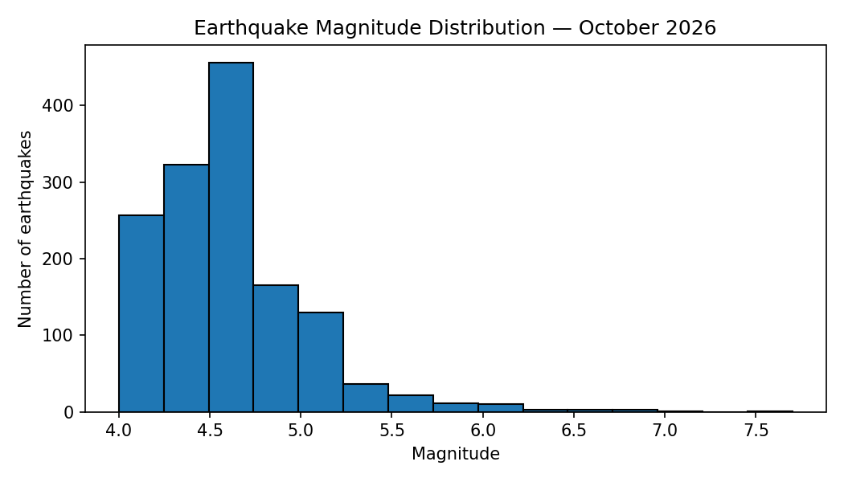
The distribution is concentrated most strongly in the 4.0–4.9 category. Events below magnitude 4.0 are not included in this catalog extract.

Figure 2. Magnitude versus depth
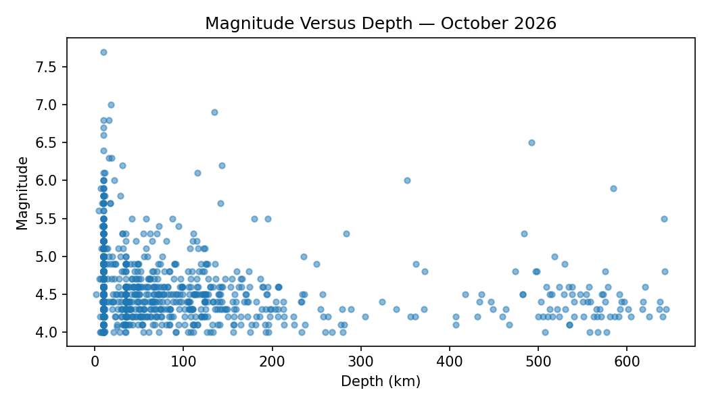
The calculated linear correlation is -0.152. The scatter plot is useful for checking the spread of magnitudes across different depths, but correlation alone does not establish a physical cause.

Figure 3. Magnitude categories
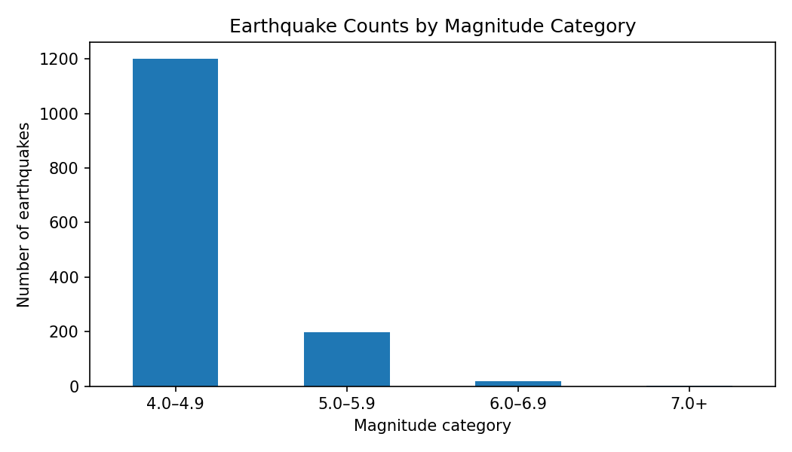
The largest group is 4.0–4.9, with 1,201 earthquakes. The remaining groups have counts of 5.0–5.9: 199, 6.0–6.9: 19, 7.0+: 2.

Figure 4. Depth categories
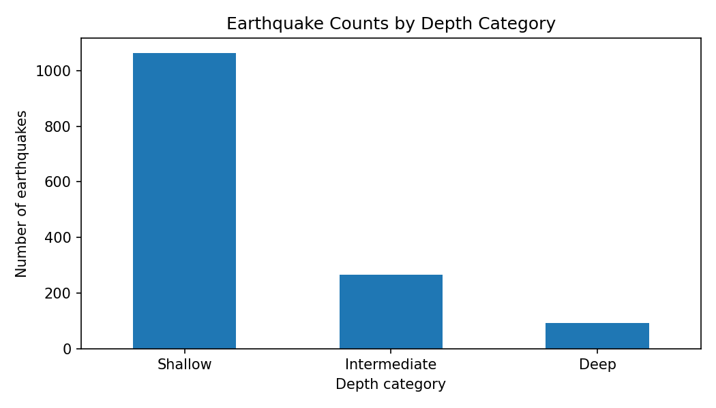
The shallow category contains 1,064 events. Counts for all groups are shallow: 1,064, intermediate: 266, deep: 91.

Engineering Interpretation
The magnitude range occurring most often was 4.0–4.9, and most earthquakes were shallow. The magnitude–depth correlation was -0.152; the scatter plot and this statistic should be considered together rather than treating the correlation as proof of a strong relationship.
One event worth further engineering attention was the magnitude 7.70 earthquake near 10 km WSW of Pitaloza Arriba, Panama, at 10.0 km depth. It was selected because it meets a magnitude-and-depth screening criterion. The dataset alone cannot establish how much ground shaking or structural damage occurred.
Magnitude describes the size of an earthquake, while depth affects the distance seismic waves travel before reaching the surface. Engineering impacts also depend on distance from the fault, soil conditions, the frequency content and duration of shaking, and the design and condition of buildings, bridges, and other infrastructure.

Limitations and Additional Data
This analysis covers only one month and excludes events below magnitude 4.0. Detection, reporting, and catalog revisions can also affect the data. Worldwide event counts do not directly measure risk to any specific city or structure.
A more complete study would add recorded ground accelerations, distance to exposed communities, local soil and geologic information, building inventories, design standards, and observed damage. Those variables would help connect earthquake characteristics to structural performance.

Conclusion
In this October 2026 dataset, the most frequent magnitude group was 4.0–4.9, and the most frequent depth group was shallow. Python made it possible to summarize and visualize the catalog consistently. The results are a useful first screening step, but magnitude and depth alone are insufficient to predict damage.

Data Source
USGS Earthquake Catalog (ComCat), FDSN Event API: https://earthquake.usgs.gov/fdsnws/event/1/query?format=csv&starttime=2026-10-01&endtime=2026-11-01&minmagnitude=4&orderby=time

